**4 . ReactJS-HOL**

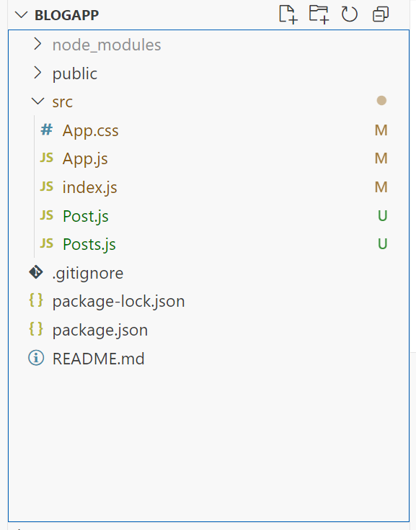

**Post.js**  
  
class Post {

  constructor(id, title, body) {

    this.id = id;

    this.title = title;

    this.body = body;

  }

}

export default Post;

**Posts.js**  
  
import React from 'react';

import Post from './Post';

class Posts extends React.Component {

  constructor(props) {

    super(props);

    this.state = {

      posts: [],

      error: null

    };

  }

  loadPosts() {

    fetch('https://jsonplaceholder.typicode.com/posts')

      .then(response => {

        if (!response.ok) {

          throw new Error('Failed to fetch posts');

        }

        return response.json();

      })

      .then(data => {

        const postList = data.map(item => new Post(item.id, item.title, item.body));

        this.setState({ posts: postList });

      })

      .catch(error => {

        this.setState({ error: error.message });

      });

  }

  componentDidMount() {

    this.loadPosts();

  }

  componentDidCatch(error, info) {

    alert("An error occurred in Posts component: " + error);

  }

  render() {

    const { posts, error } = this.state;

    if (error) {

      return <div>Error: {error}</div>;

    }

    return (

      <div>

        <h2>Post List</h2>

        {posts.map(post => (

          <div key={post.id}>

            <h3>{post.title}</h3>

            <p>{post.body}</p>

            <hr />

          </div>

        ))}

      </div>

    );

  }

}

export default Posts;

**App.js**

import React from 'react';

import './App.css';

import Posts from './Posts';

function App() {

return (

<div className="App">

<h1>Blog Post List</h1>

<Posts />

</div>

);

}

export default App;

**index.js**  
  
import React from 'react';

import ReactDOM from 'react-dom/client';

import './index.css';

import App from './App';

const root = ReactDOM.createRoot(document.getElementById('root'));

root.render(

<React.StrictMode>

<App />

</React.StrictMode>

);

**App.css**

.App {

text-align: center;

font-family: Arial, sans-serif;

padding: 30px;

background-color: #f9f9f9;

}

